Simple Storage Service (S3)
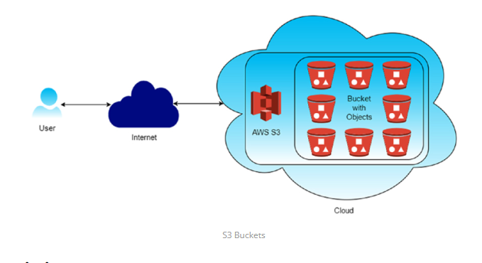1. Versioning: Versioning in Amazon S3 is a feature that allows you to keep multiple versions of an object in the same bucket. Whenever you upload a new version of an object with the same key (name) as an existing object, S3 doesn't overwrite the existing object but instead creates a new version of it. This means you can retain and access previous versions of objects, providing an additional layer of protection against accidental deletions or overwrites
- Accidental Deletion Protection :: With versioning enabled, if you accidentally delete an object, you can still retrieve previous versions of it, preventing data loss.
- Accidental Overwrite Protection::Versioning prevents accidental overwrites of objects. Even if you upload a new version of an object with the same name, the previous versions are preserved.
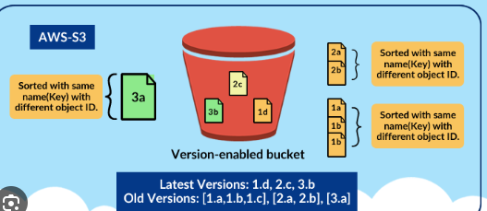
- Cross-Region Replication: Cross-region replication (CRR) in Amazon S3 is a feature that automatically replicates objects from one bucket in one AWS region to another bucket in a different AWS region. This provides redundancy and disaster recovery capabilities, ensuring that your data remains available even if an entire AWS region becomes unavailable.
- Disaster Recovery: Cross-region replication helps ensure business continuity by replicating critical data to a different geographic region, reducing the risk of data loss due to regional disasters or outages.
- Low-Latency Access: Users in different geographic regions can access data from the nearest region, reducing latency and improving performance.
- Compliance: Some regulatory requirements mandate data replication across multiple geographic regions for data sovereignty and compliance reasons.
- Event Notifications: S3 can trigger events (e.g., object creation, deletion) that can be routed to AWS Lambda, SNS, or SQS for processing.
- Integration: S3 seamlessly integrates with other AWS services such as AWS Lambda, Amazon CloudFront, AWS Glue, Amazon Athena, and Amazon EMR, enabling you to build powerful data processing and analytics workflows.

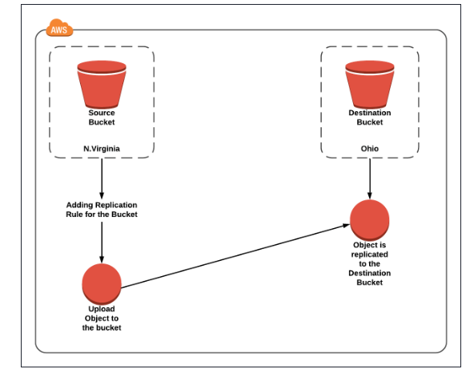

1.Creating an S3 bucket, upload an object, and enable public access
1️⃣ Create an S3 Bucket (with Public Access Enabled)
Step 1: Open S3 Service
- Login to AWS Management Console
- Go to Services → S3
- Click Create bucket

Step 2: Bucket Configuration
- Bucket name: my-public-bucket-123
- Region: Choose nearest region

Step 3: Disable Block Public Access (IMPORTANT)
Under Block Public Access settings for this bucket:
❌Uncheck Block all public access
You must uncheck ALL options:
✔ Check I acknowledge that this bucket will become public
👉 Click Create bucket
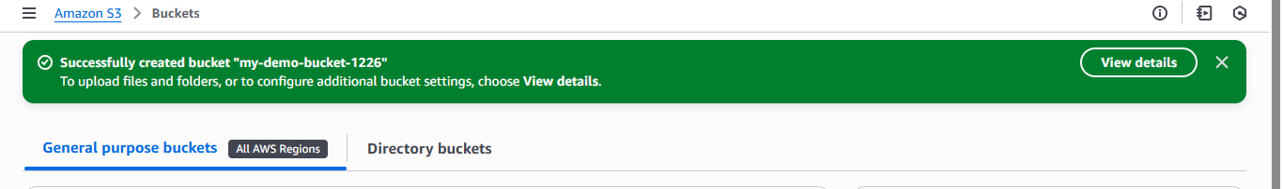

2️⃣ Enable Public Access at Bucket Level (ACL)
Step 4: Open the Bucket
- Click on the bucket name
- Go to Permissions tab

Step 5: Edit Bucket ACL
- Scroll to Access Control List (ACL)
- Click Edit
Under Public access:
- Everyone (public access) → ✔ Read access
✔ Save changes
📌 This allows public access at bucket level
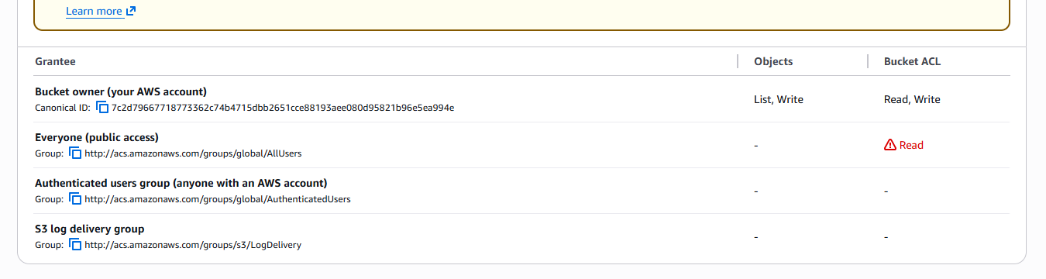

3️⃣ Upload Object to the Bucket
Step 6: Upload File
- Go to Objects tab
- Click Upload
- Click Add files
- Select file (e.g., image.jpg)
- Click Upload

4️⃣ Enable Public Access for Object (ACL)
Step 7: Object-Level ACL Permission
- Click on uploaded object
- Go to Permissions tab
- Scroll to Access Control List (ACL)
- Click Edit
Under Public access:
- Everyone (public access) → ✔ Read access
✔ Save changes
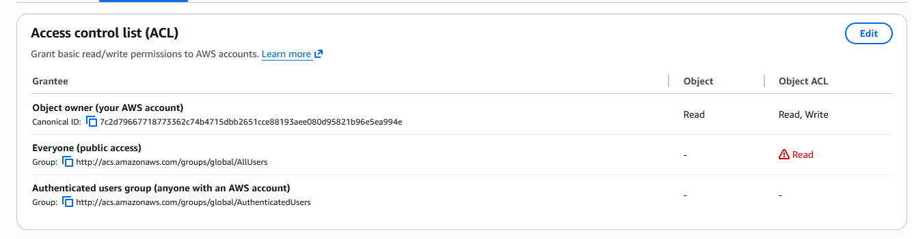

5️⃣ Verify Public Access
Step 8: Test Object URL
- Copy Object URL
- Open in browser (incognito)
✔ Object should be accessible without login
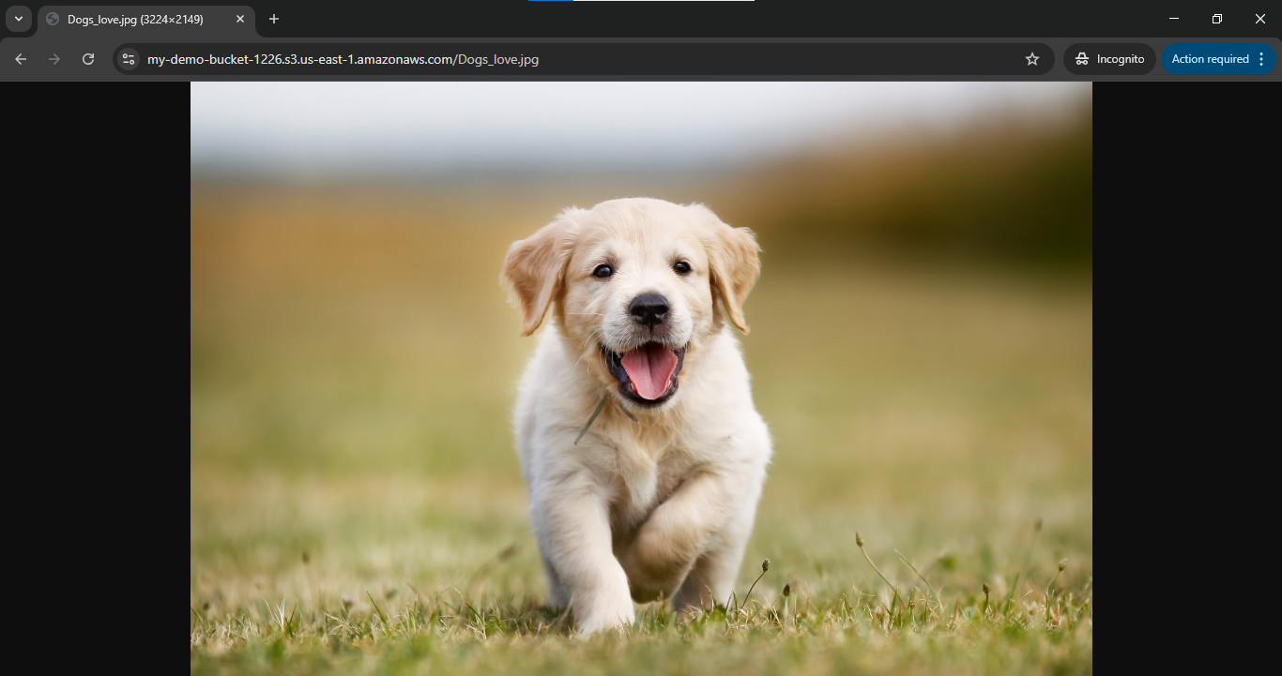

2. S3 Versioning & Cross-Region Replication

1️⃣ Enabling Versioning in S3 (with Output Scenario)
🔸 Objective
To enable version control on an S3 bucket and observe object versions.

🔸 Steps to Enable Versioning
- Open AWS Management Console
- Navigate to S3
- Select the bucket
- Go to Properties tab
- Scroll to Bucket Versioning
- Click Edit
- Select Enable
- Click Save changes
✔ Versioning is now enabled
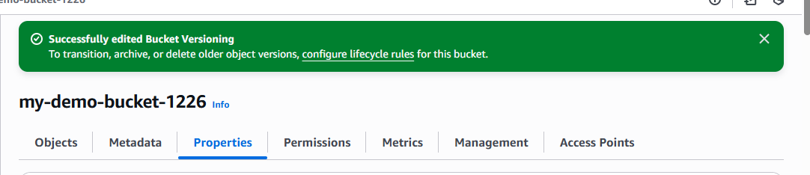

🔸 Output Scenario (What You Observe)
Step A: Upload Object
- Upload file: report.pdf
📌 Output:
- Version ID is assigned automatically

Step B: Modify and Re-upload Same Object
- Upload report.pdf again (same name)
📌Output:
- Old version is preserved
- New version becomes current
- 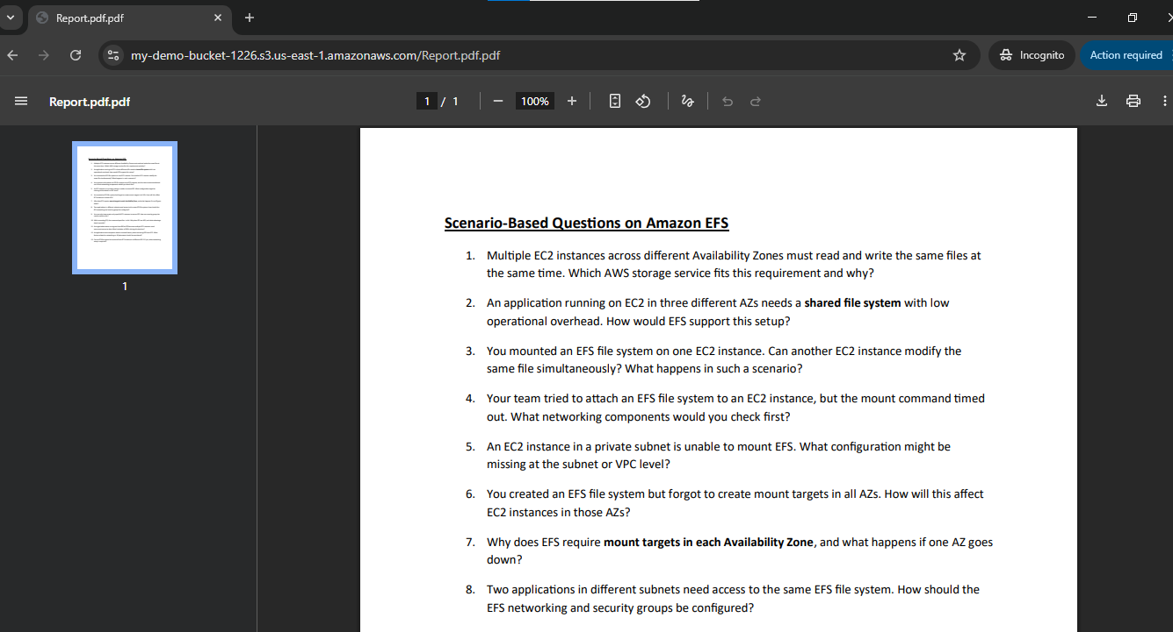

Step C: Delete Object
- Click Delete on report.pdf
📌 Output:
- Object appears deleted
- A Delete Marker is created
- Older versions still exist and can be restored

2️⃣Cross-Region Replication (CRR)
🔸 Objective
To replicate objects from one bucket to another in a different region using AWS-managed permissions.

🔸 Prerequisites (Very Important)
✔Versioning must be enabled on both buckets
✔ Source and destination buckets must be in different regions
✔ AWS Academy automatically handles replication permissions

Step 1️⃣ Create Destination Bucket
- Go to S3 → Create bucket
- Bucket name: dest-crr-bucket
- Select different region
- Complete bucket creation
- Enable Versioning (same steps as above)

Step 2️⃣ Create Replication Rule (Without IAM Selection)
- Open Source bucket
- Go to Management tab
- Click Replication rules
- Click Create replication rule

Step 3️⃣ Configure Replication Rule
- Rule name: academy-crr-rule
- Status: Enabled
- Scope: Apply to all objects

Step 4️⃣ Choose Destination Bucket
- Select Another bucket
- Choose Destination bucket
- Confirm different region
📌 AWS Academy Note:
You will see an option like:
"AWS will create and manage the required permissions automatically"
✔ Select Use AWS-managed role / default role

Step 5️⃣ Replication Options
- Replicate:
  - ✔ New objects
  - ❌ Existing objects (optional, depends on Academy permissions)
- Encryption: Leave default
Click Save
✔ Replication rule is now active

3️⃣ CRR Output Scenario (What You Observe)
🔸Step A: Upload New Object to Source Bucket
- Upload file: image.png
📌 Output:
- Object is uploaded normally

🔸 Step B: Verify Destination Bucket
- Open destination bucket
- Object image.png appears automatically
- Version ID is present
✔ Replication successful
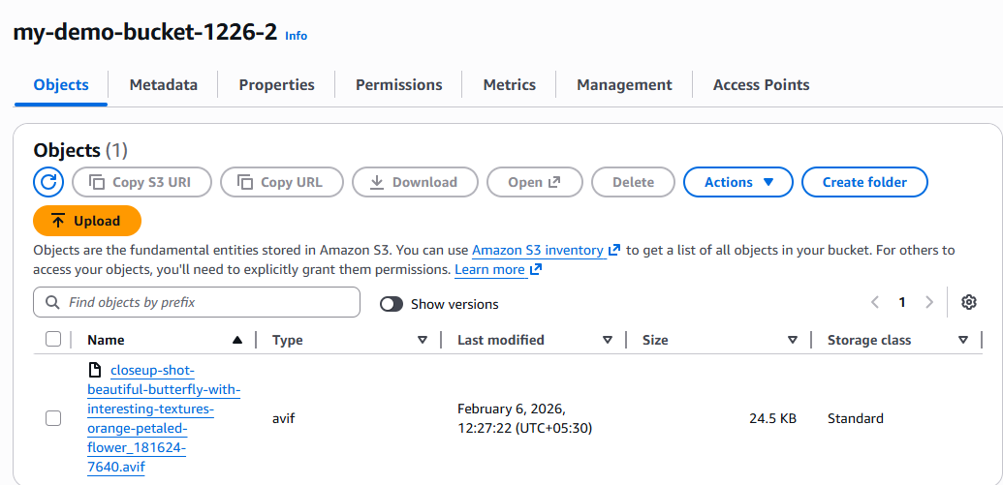

  - Static Website Hosting in S3
(Using Bucket-Level & Object-Level Permissions – ACL Method)

🔹 Objective
To host a static website in Amazon S3 using index.html and error.html, and allow public access using ACL-based bucket and object permissions.

🔹 Prerequisites
- AWS / AWS Academy account
- Two files:
  - index.html
  - error.html

1️⃣ Create an S3 Bucket
- Login to AWS Management Console
- Go to Services → S3
- Click Create bucket
- Enter:
  - Bucket name: my-static-site-bucket-123
  - Region: Nearest region
- Under Block Public Access:
  - ❌ Uncheck Block all public access
  - ✔ Acknowledge the warning
- Click Create bucket
✔ Bucket created successfully

2️⃣ Upload Website Files
- Open the bucket
- Go to Objects tab
- Click Upload
- Click Add files
- Select:
  - index.html
  - error.html
- Click Upload
✔ Files uploaded
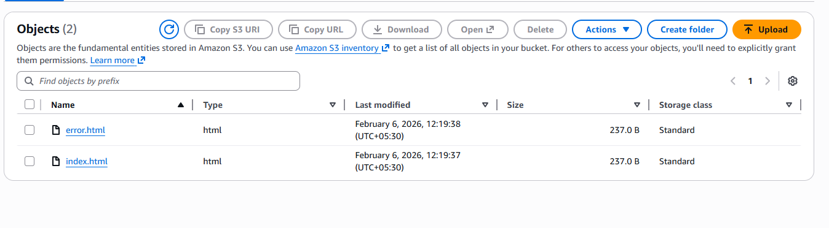

3️⃣ Enable Static Website Hosting
- Go to Properties tab
- Scroll to Static website hosting
- Click Edit
- Select Enable
- Choose Host a static website
- Enter:
  - Index document: index.html
  - Error document: error.html
- Click Save changes
✔ Static website hosting enabled

4️⃣ Enable Bucket-Level Public Access (ACL)
🔹 Purpose
Allows public users to access objects inside the bucket.

- Go to Permissions tab
- Scroll to Access Control List (ACL)
- Click Edit
- Under Public access:
  - Everyone (public access) → ✔ Read
- Click Save changes
✔ Bucket-level public read access enabled
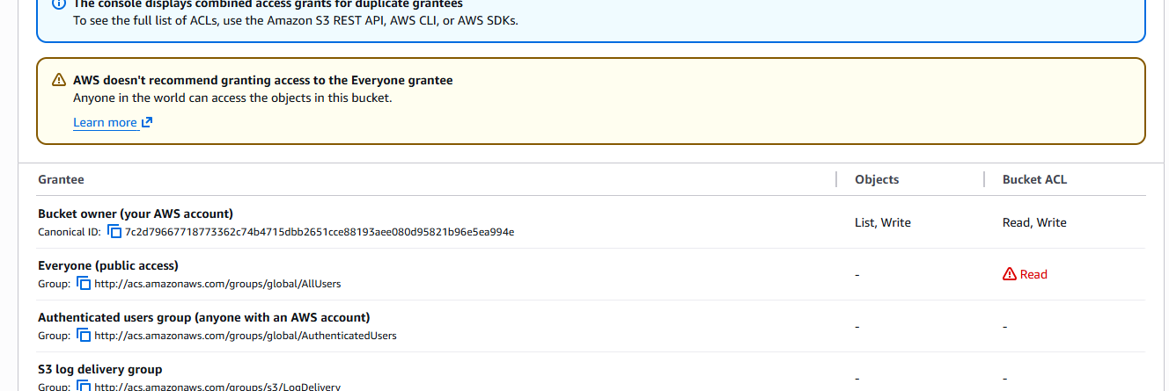

5️⃣ Enable Object-Level Public Access (ACL)
Steps (For Each File)
- Go to Objects tab
- Click on index.html
- Go to Permissions
- Scroll to Access Control List (ACL)
- Click Edit
- Under Public access:
  - Everyone (public access) → ✔ Read
- Save changes
🔁 Repeat the same steps for error.html
✔ Object-level public access enabled

6️⃣ Access the Static Website
- Go to Properties
- Scroll to Static website hosting
- Copy the Bucket website endpoint
- http://my-static-site-bucket-123.s3-website-region.amazonaws.com
- Paste into browser
✔ index.html page loads successfully
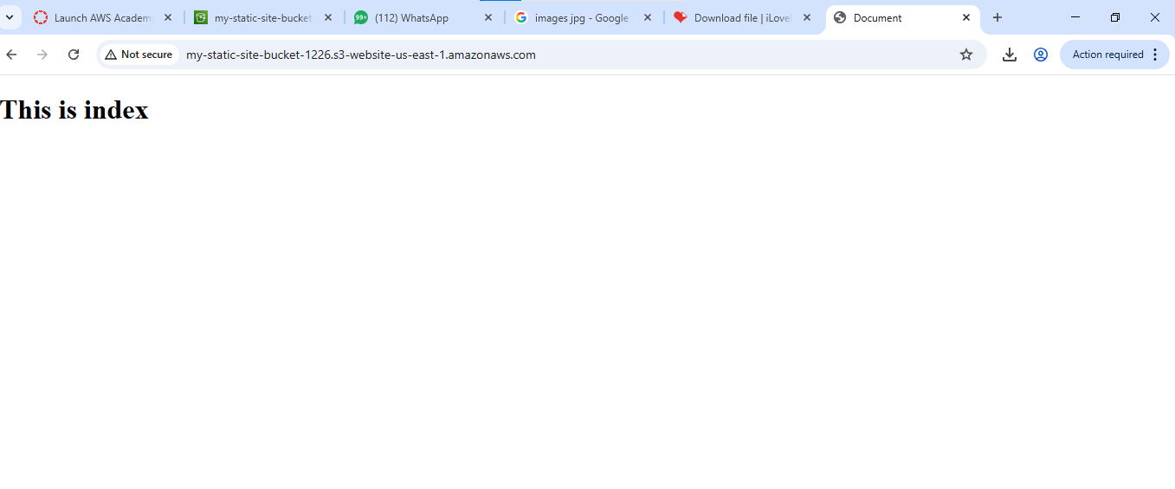

7️⃣ Error Page Output Scenario
🔹Test Error Page
- Open an invalid URL:
- http://bucket-name.s3-website-region.amazonaws.com/invalid.html
📌 Output:
- error.html page is displayed
✔ Error page working correctly
